**Institute of Engineering & Management**

**Department of Computer Science & Engineering**

**Software Tools Laboratory for 2nd year 4th Semester 2018**

**Code: CS 492**

**Date:**28/03/2018

**Week-7**

**Assignment-1**

**Problem Statement:** Display all records of a file with a VB application.

**Screen-Shot:**

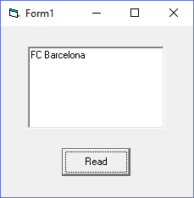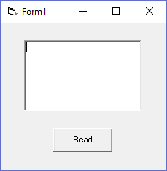 **Form-1:** Before Clicking After Clicking

**Form Code:**

**For Form-1:**Private Sub Command1_Click()  
Dim a As String  
Text1.Text = " "  
Open "C:\Users\Ankur\Desktop\prac.txt" For Input As #1  
Do  
Input #1, a   
Text1.Text = Text1.Text & a & vbCrLf  
Loop Until EOF(1)  
Close #1  
End Sub

**Assignment-2**

**Problem Statement:** Insert a record in a file. After the insert, the file will contain only the new record.

**Screen-Shot:**

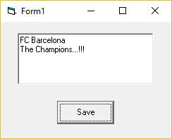 **Form-1:**

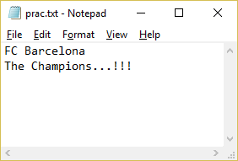 Typing on Text Box

In the text file after saving

**Form Code:**

**For Form-1:**Private Sub Command1_Click()  
Dim a As String  
Open "C:\Users\Ankur\Desktop\prac.txt" For Output As #1  
Print #1, Text1.Text  
Close #1  
End Sub

**Assignment-3**

**Problem Statement:** Insert some in a file. The new records are inserted after some previous data.

**Screen-Shot:**

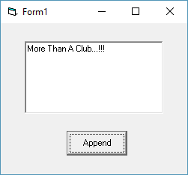 **Form-1:**

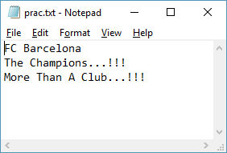Typing in the text box

After saving the text in the file

**Form Code:**

**For Form-1:**Private Sub Command1_Click()  
Open "C:\Users\Ankur\Desktop\prac.txt" For Append As #1  
Print #1, Text1.Text & vbCrLf  
Close #1  
End Sub

**Assignment-4**

**Problem Statement:** Create a vb form. The form will contain four text boxes captioned with NAME, DEPARTMENT, ROLL, and MOBILE NO. Insert the desired value to every text boxes and select the desired file where you will save these values.

**Screen-Shot:**

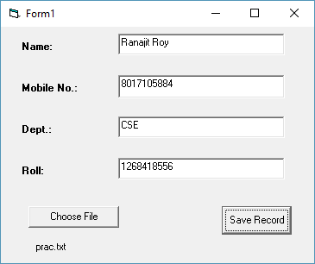 **Form-1:**

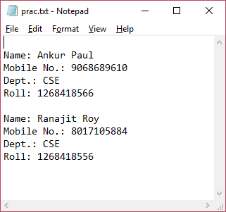Data Entry

After saving the entry in the  
text file

**Form Code:**

**For Form-1:**Dim a As String  
  
Private Sub Command1_Click()  
Open a For Append As #1  
Print #1, "Name:" + Text1.Text + vbCrLf; "Mobile No:" + Text2.Text + vbCrLf + "Department:" + Text3.Text + vbCrLf + "Roll No:" + Text4.Text + vbCrLf  
End Sub  
  
Private Sub Command2_Click()  
CommonDialog1.Filter = "text files(*.txt) | *.txt"  
CommonDialog1.ShowOpen  
a = CommonDialog1.FileName  
Label5.Caption = CommonDialog1.FileTitle  
End Sub